Suggestions for activities to support your child’s learning and development – Early Years
Week 8 11th – 15th May 2020

Sensory Play
Sensory play is any play activity which can involve touch, smell, taste, sight and hearing. This can be provided with a plate of jelly, ice, rainbow rice, or outdoor mud cakes. Sensory play stimulates exploration and the building blocks of science and investigation
Dinosaur eggs – a simple science activity as well as a fun sensory play activity!
Ice melting is an activity for children of all ages and frozen dinosaur eggs are perfect for your dinosaur fans and super easy to make, kids will be hatching their favorite dinosaurs in no time.
Place a small dinosaur figure inside a balloon, fill with water and tie a knot. Place in the freezer until frozen. Snip the knot of the balloon and slip the frozen egg out.
You could also use an ice cube tray and try freezing other items e.g. toy cars, flowers or leaves.
Encourage your child to experiment with different resources (with appropriate supervision) to aid the defrosting process- add hot/cold water etc.
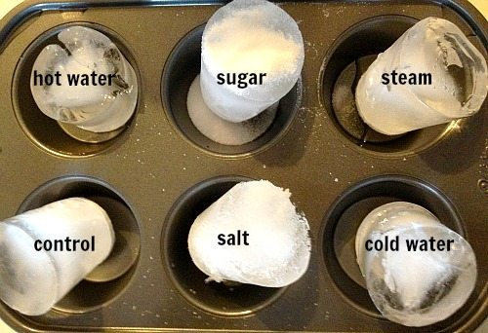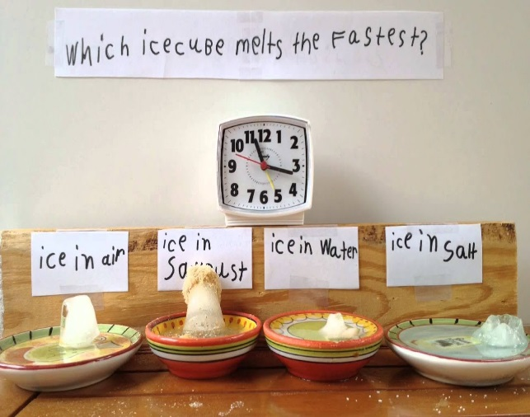

Coloured Spaghetti
Cook your spaghetti as normal, drain and rinse with cold water, mix 1tbsp of vegetable oil. This will stop the spaghetti sticking and allows the food colouring to stick to it better. Cool and add your choice of food colouring and mix in well until all of the spaghetti is covered.
This can be played with straight away or you can cover it with cling film and keep in the fridge.
Add bowls, spoons and any plastic animals to create even more interest and extend the play. Depending on what has been added to the spaghetti, you could cover it up and use it again within a couple of days for more fun!
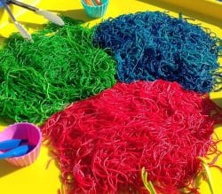
Printing numbers or letters with sand
Encourage your child to make some marks on some card or paper, numbers, letters or even a drawing, trace over the shapes to make it thicker and then let your child cover the shapes with glue you can use flour and water for a really easy mix.
Give your child some choices as how to cover the glue – they might want to collect soil from the garden, sand, chopped up or torn leaves, flower petals, rice, or grains.
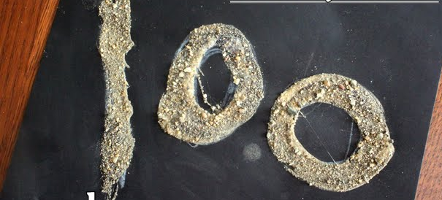

Pick a letter - Cut out some letters to add to a pot or use fridge magnet letters, and spread out some toys or objects that start with the letters chosen.
Take it in turns to pick a letter out of a pot then match it to the object which starts with that sound.
Kim’s game 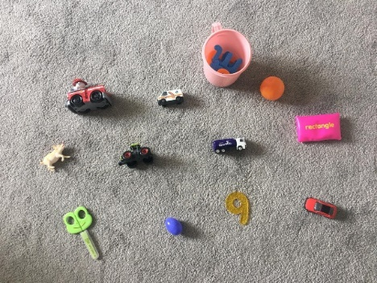
Linked to a sound theme. Choose some items or toys that all begin with the same sound.
Look and say what’s in the box. Cover up and see if they can remember them all. Then take one away, can they recognise what’s missing?
Treasure bag 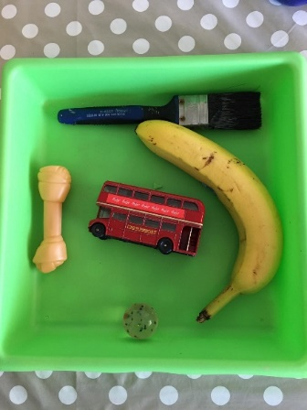
Children love to look for things when they are out and about.
Ask them to look for special sticks, a feather, a smooth stone, an acorn or a snail shell. Put the treasure in a paper bag and take it home. Talk to your children about what they have found and how it got there.
Make a head-dress – with a simple folded strip of paper and use your treasure to make a headband.
