Suggestions for activities to support your child’s learning and development – Early Years
Week 4 – 13th April to 17th April 2020
Can you find a rainbow?
As you may have noticed, young children love colour! It catches their eye and grabs their attention. Colour is not only exciting for a child, but it also helps with their learning and allows them to recognise significant visual hues such as red as a code for danger and the meaning behind traffic lights.
Encourage your child to collect toys or items from around the house to match the rainbow colours
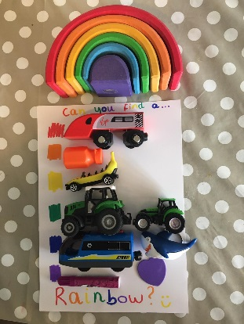
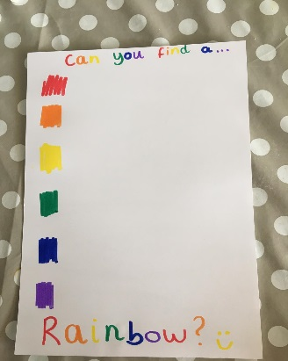

Mark making and patterns with playdough
Early mark making will give your child the chance to explore their creativeness for the pure enjoyment of it and will encourage children to mark make in the future.
Provide a collection or toys to make prints in the playdoh, using children’s favourite toys will help them to engage and you can then extent this to other natural resources – stones, leafs or shells.
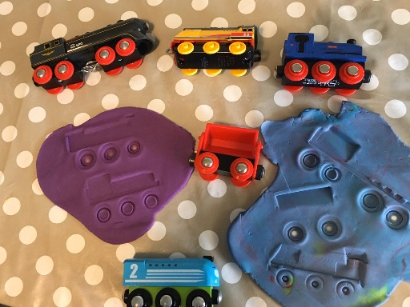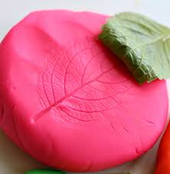

Homemade paints
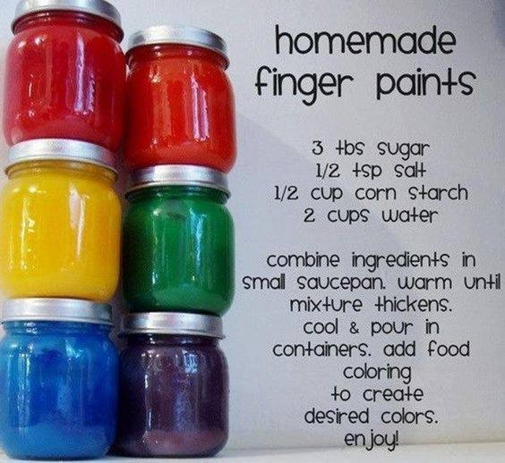

Toy wash
Fill a sink, or plastic bin or bowl with water. Provide a towels and a box of toys that kids can wash (toys with electronic pieces should be avoided) and let your children clean away.
To add to this you could let the children mix garden soil with water first to really get toys dirty before cleaning – dress them appropriately and help them learn about good handwashing!
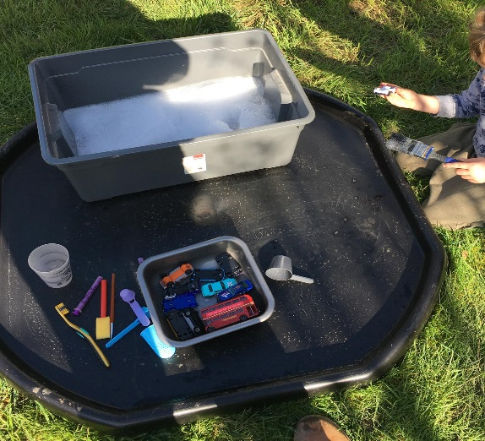

Sinking or Floating? Your child will enjoy guessing whether the object will float or sink and immediately comparing their predictions with the actual results. The popcorn is a favorite.
Gather a collection of household items and or toys, discuss with your child if they think the items will sink or float
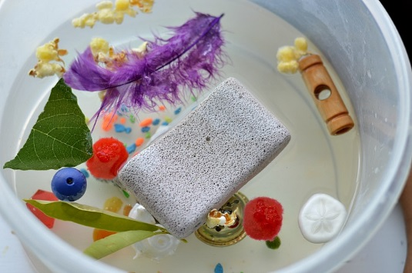
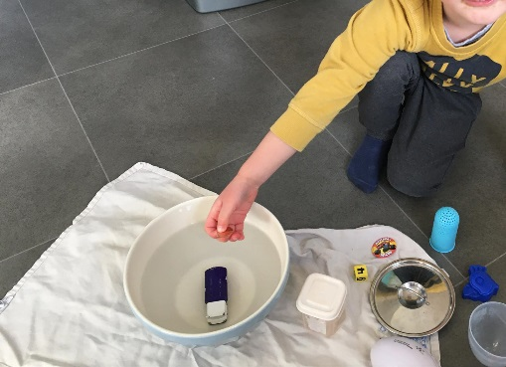
Den building
Den building offers a range of advantages to children of all ages, from physical development to problem solving skills. Children are able to build on their learning by thinking creatively and putting their ideas into reality. Creating dens will give children the opportunity to think outside of the box and problem solve in order to create a structure.
Encourage your child to use their own ideas to set up a tent inside or in the garden with sheets or blankets over some chairs or a table, let the children get comfy with pillows and blankets, healthy snacks. You could turn out the lights (if indoors) and give them flashlights to make shadow animals, add some cuddly toys and some books.
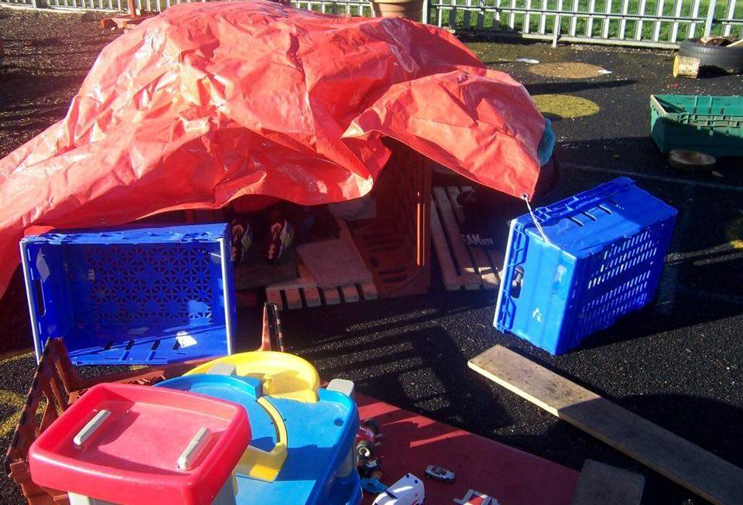
Threading
Set up a bowl of O – shaped cereal with liquorice laces or shoelaces/string and encourage their threading skills. They can also copy patterns and encourage them to use their counting skills
You can also use pasta and straws and using playdoh to stabilise
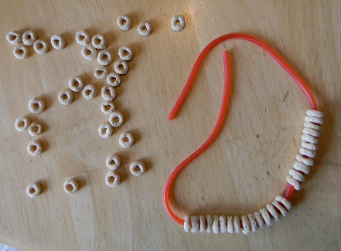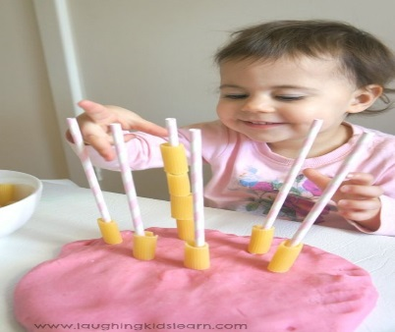

Sock matching
Get the children involved with the household chores, or simply create a game for the children, empty your sock draw out and encourage the children to match by size, pattern, colour use an egg timer or the stop watch on a phone to see who can do it the quickest.
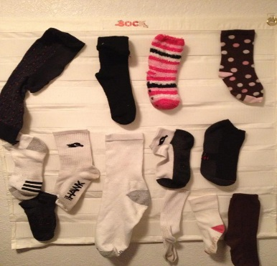
Make a simple ball with two or three clean pairs of large socks rolled inside each other, you can play sock ball soccer, throw and catch, basketball, throwing their balls into a laundry basket or cardboard box at various heights and angles.
Memory games are important for young children’s growing brains
Head shoulders knees and toes, or any other songs. Toddlers are natural singers and it is great practice for exercising their memories, simple but entertaining.
Gather some of the children’s favourite toys, books and objects, they can help with this put them together and talk about what’s there.
Ask the child to close their eyes and turn around, remove some items. Then get them to turn around and list what is missing.
Take turns with your child to test your memory.
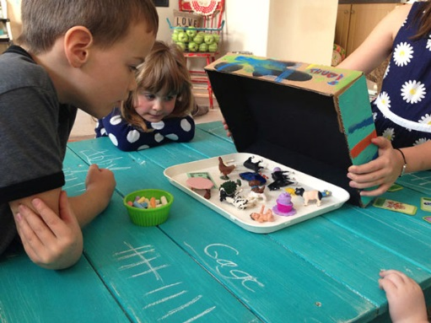

Collage or drawings of their favourite food
Encourage your child to talk about healthy meals and snacks and be involved in preparing food and simple cooking skills, weighting out ingredients, chopping, and mixing, pouring, talk about colours, sizes, shapes, taste, and smell.
Children love to help and be praised, they could be laying the table, washing up, chopping fruit and veg for snacks (supervised), spreading their own spread on crackers.
For this activity you will need a paper plate or a circle of paper, crayons or pencils, child safe pencils food magazine, glue (flour and water)
Talk to your child about foods they like, then look for pictures in magazines, help them tear or cut out their favourite and stick them on to their paper plate.
